UK Impact Assessment: Data Protection Regulation

The EU Commission Impact Assessment concludes that the proposed Data Protection Regulation will be beneficial for the EU economy because it reduces the administrative cost that arises from fragmentation of current law, and give individuals greater confidence in using online services.

The UK has carried out its own Impact Assessment of the costs and benefits of the proposals. While there are benefits from the Regulation, such as a reduction in legal fragmentation, the UK Impact Assessment concludes that these benefits are outweighed by the costs of additional administrative and compliance measures that the Regulation introduces. The Impact Assessment concludes that the Regulation in its current form could have a net cost to the UK economy of £100-£360 million per annum (in 2012-13 earnings terms).

Monetised costs and benefits

Table 1 gives the breakdown for the monetised costs and benefits presented in the UK Impact Assessment. It shows that the Regulation is expected to deliver economic benefits through a reduction in legal fragmentation, a reduction in the loss of personal data, and savings from controllers no longer having to notify with the supervisory authority. However, these benefits are outweighed by the cost of notifying breaches to the supervisory authority, carrying out data protection impact assessments, employing data protection officers, demonstrating compliance with the Regulation and the cost of additional tasks placed on the supervisory authority (ICO).

Table 1: Annual costs and benefits of the data protection Regulation to the UK; £million, 2012-13 earnings terms
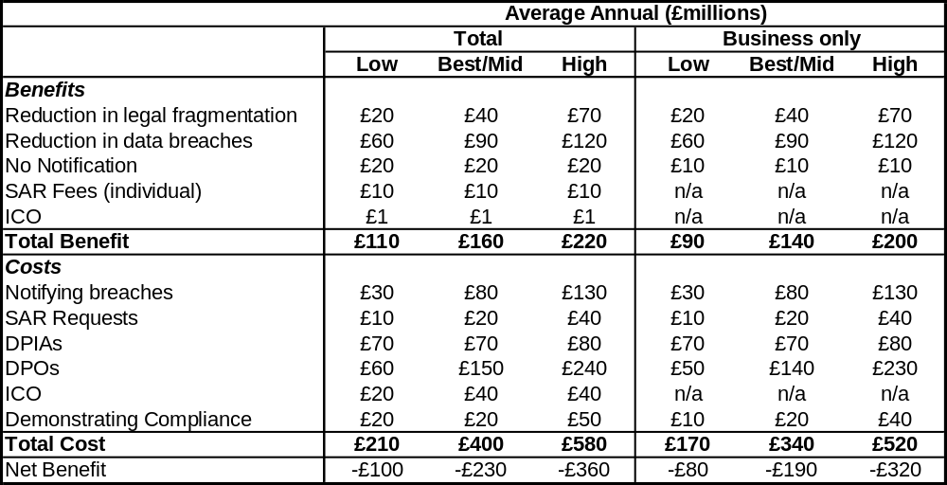
Note: figures have been rounded to the nearest £10million and so totals may not sum.

The most costly parts of the Regulation are expected to arise from the requirement to notify breaches of personal data to the supervisory authority, the requirement to carry out data protection impact assessments and the requirement to employ a data protection officer. If the prescription in these requirements, and other articles, could be lowered, this would significantly reduce the net cost of the Regulation to the UK economy.

EU Commission Analysis

The EU Commission Impact Assessment concluded that the proposals would result in a net benefit of €2.3 billion per annum to the EU economy. This figure only includes administrative burdens and so ignores a number of compliance costs included in the UK assessment, such as data protection officers, data protection impact assessments, and additional costs to the supervisory authority.

The UK Impact Assessment shows that the administrative and compliance costs of the Regulation significantly outweigh the benefits. Therefore, by ignoring compliance costs the EU Commission has significantly over-stated the benefits of the proposed data protection Regulation.

Non monetised costs and benefits

The Regulation also has a number of other costs and benefits which it was not possible to monetise in the UK Impact Assessment. These include the following:

Data portability and right to be forgotten: data controllers have expressed concern that these articles will be costly to implement as they will require data controllers to update their IT systems. One marketing company estimated that data portability and right to be forgotten clauses could require a one off system development costing £100,000, while a large telecommunications company estimated that data protection by design, data portability and the right to be forgotten would cost £5 million. However, giving individuals greater control over their personal data could have positive economic benefits if it encourages greater usage of services that require individuals to share their personal data.

Consent, profiling and definition of personal data: the requirement for consent to be explicit, the restriction on profiling, and extending the scope of personal data to include online identifiers, are together likely to be detrimental to growth in the technology sector due to the restrictions they place on direct marketing. The Direct Marketing Association (DMA UK) estimated that the Regulation could cost the UK £47 billion in lost sales if it is no longer possible to use web analytics for marketing purposes.

Administrative sanctions: the Regulation also proposes a set of administrative sanctions which are excessive compared to the harm caused and could therefore be costly for business. Excessively high fines can discourage new-entrants into the market, may drive marginal firms out of the market, and do not give the supervisory authority the discretion to work with controllers to improve compliance. Excessively high fines may also lead to data controllers spending unnecessary amounts to ensure compliance, at the expense of other areas.

Conclusion

The UK supports a data protection framework that will reduce legal fragmentation and support the rapidly growing digital economy. While a proportionate and sensible data protection system can help economic growth, an unwieldy and burdensome regime can have the opposite effect. Therefore, we would like to see a reduction in the level of prescription in the Regulation so that that the costs are proportionate to the risk involved in any data processing.

DMA (2012), ‘Putting a price on direct marketing.

